STEP 1: Download and install the VPN From the browser(proton VPN)

STEP 2:CREATE A ACCOUNT SIGN IN WITH YOUR EMAIL ID.

DOWNLOAD IT FOR WINDOWS

STEP 3: Connect to a VPN server. After clicking connect option.

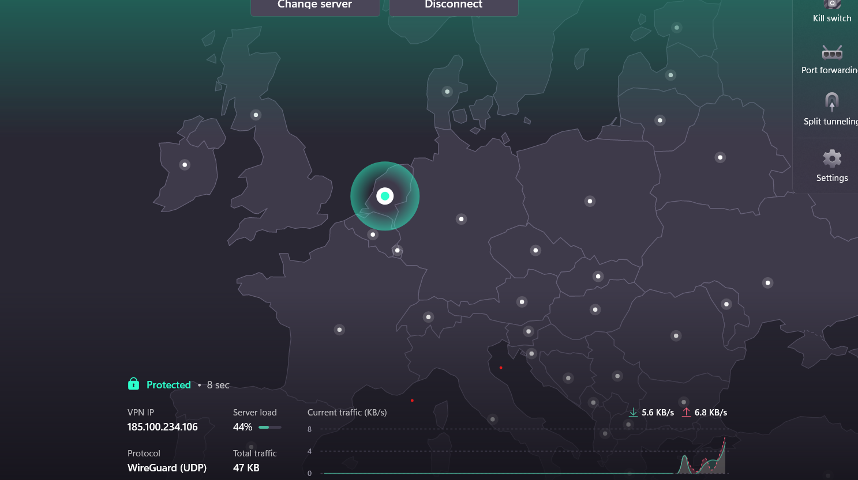

ITS SHOWS THAT VPN HASS SUCCESSFULLY CREATED AND ALSO PROTECTED AND ALSO SHOWING THE IP ADDRESS WHICH IS ALSO PROTECTED BETWEEN THE TWO NEIGHBOURS

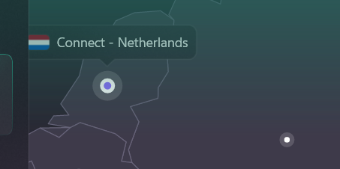

##ITS SHOW THAT ITS CONNECTED TO NETHERLANDS

STEP 4: Verify your IP address has changed (use whatismyipaddress.com)

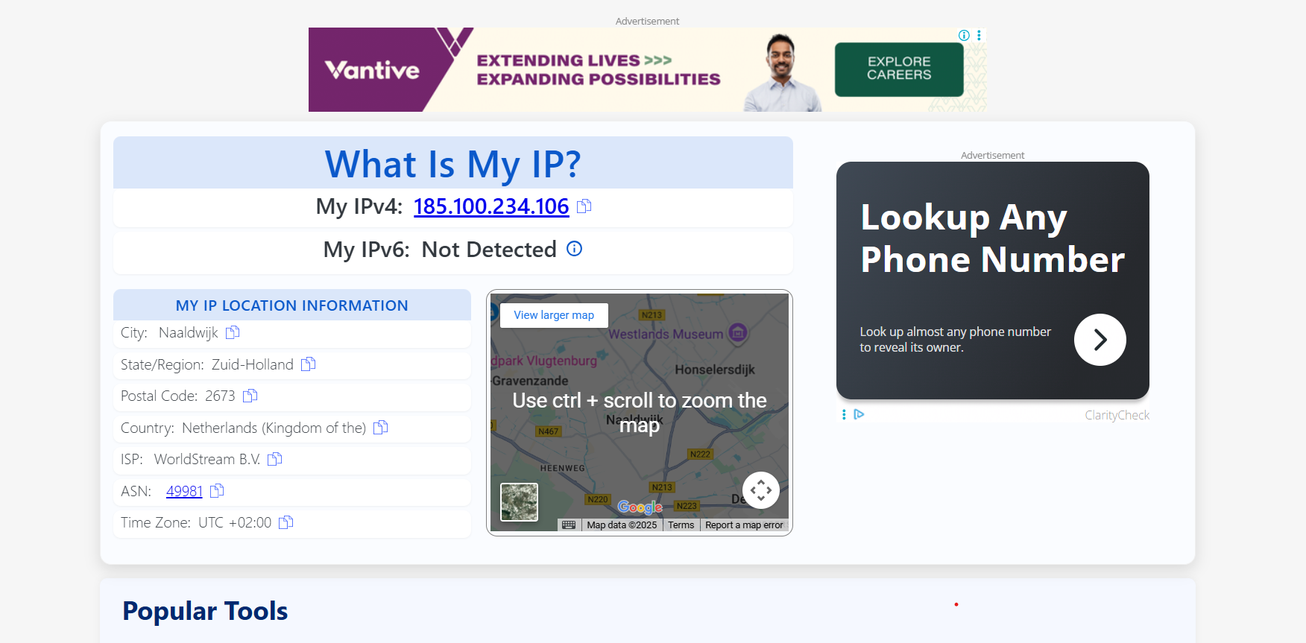

STEP 5:ITS SHOWS THAT ENCRPTED TUNNEL HASS CREATED.

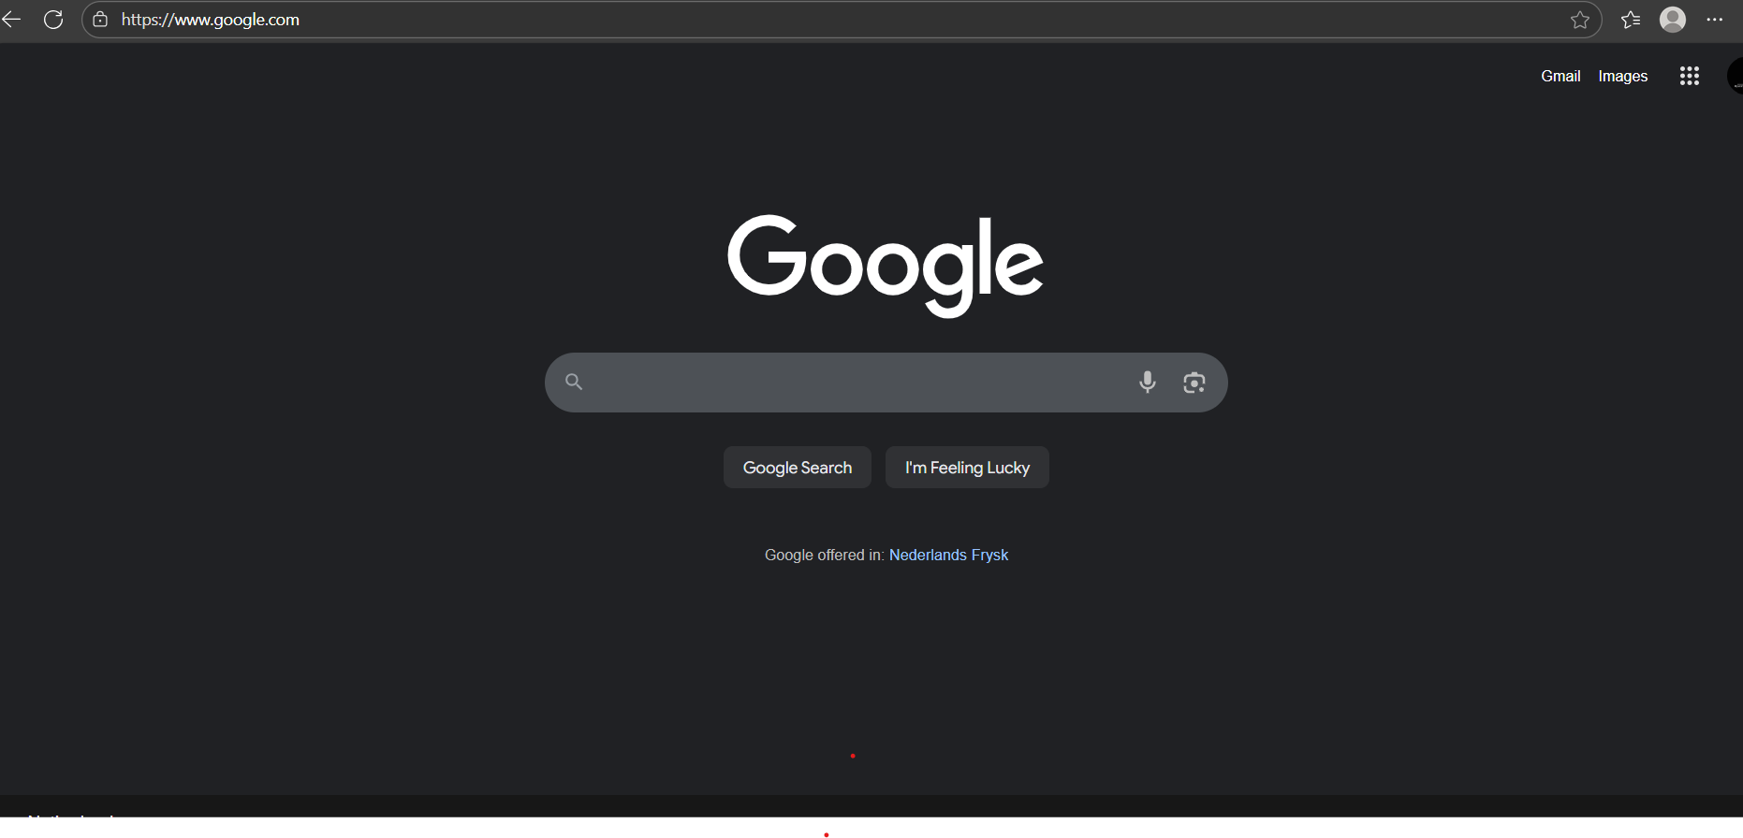

STEP 6:NOW DISCONECT AND CHECK YOU LOCATION NOW IT WILL COMES TO YOUR ORIGINAL STATE.

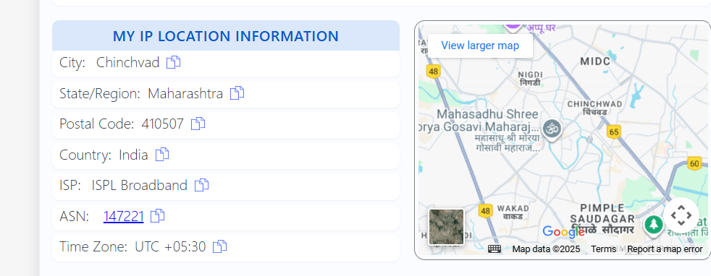

##AND ALSO LIVE LOACTIONS INDIA

**##Research VPN Encryption and Privacy Features**

Most reputable VPNs use strong encryption standards like:

* **AES-256 encryption**: Military-grade, widely trusted.
* **OpenVPN / WireGuard protocols**: Secure and efficient tunneling methods.
* **No-logs policy**: Ensures the VPN does not store your browsing history.
* **Kill Switch**: Disconnects internet if VPN drops to prevent IP leaks.
* **DNS Leak Protection**: Prevents queries from bypassing the tunnel.

**Summary – VPN Benefits and Limitations**

**🔹 Benefits of Using a VPN**

1. **Online Privacy & Anonymity** – Masks your real IP address, making it harder for websites, advertisers, and even ISPs to track you.
2. **Data Encryption** – Secures traffic against hackers, especially on public Wi-Fi networks (cafes, airports, hotels).
3. **Bypass Geo-Restrictions** – Allows access to region-locked websites, apps, and streaming services.
4. **Avoid ISP Throttling** – Some ISPs slow down streaming or gaming traffic; VPNs can hide this usage.
5. **Security for Remote Work** – Protects sensitive company data when working outside the office.

**🔸 Limitations of Using a VPN**

1. **Reduced Speed** – Encryption and rerouting can cause slower connections, especially on free VPNs.
2. **Limited Data & Servers (Free Plans)** – Many free VPNs cap bandwidth and offer only a few server locations.
3. **Trust Issues** – Some free VPNs log or sell user data, defeating privacy goals.
4. **Not a Complete Shield** – VPNs don’t protect against malware, phishing, or unsafe downloads.
5. **Blocked by Some Services** – Certain streaming platforms, banks, and websites actively detect and block VPN traffic.